[TC-MR12-38] Official Quote Automation – Request Official Quote – Suffix

Result 1: BUG

Testing sequence:
1. Select "New Suffix" from the form "Select Official Quote Mode".
2. We receive a list of official quotes populated only with EEAS1 00001.
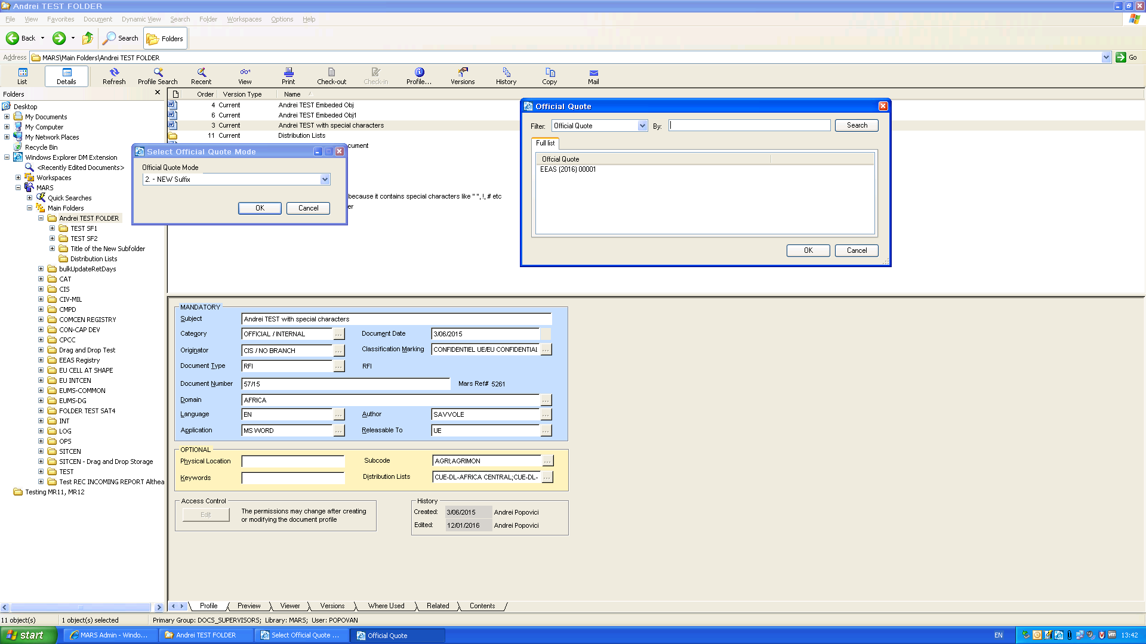
3. We click "Cancel" in both forms.
4. At the second attempt to receive a "New Suffix" we don't receive the populated list anymore!
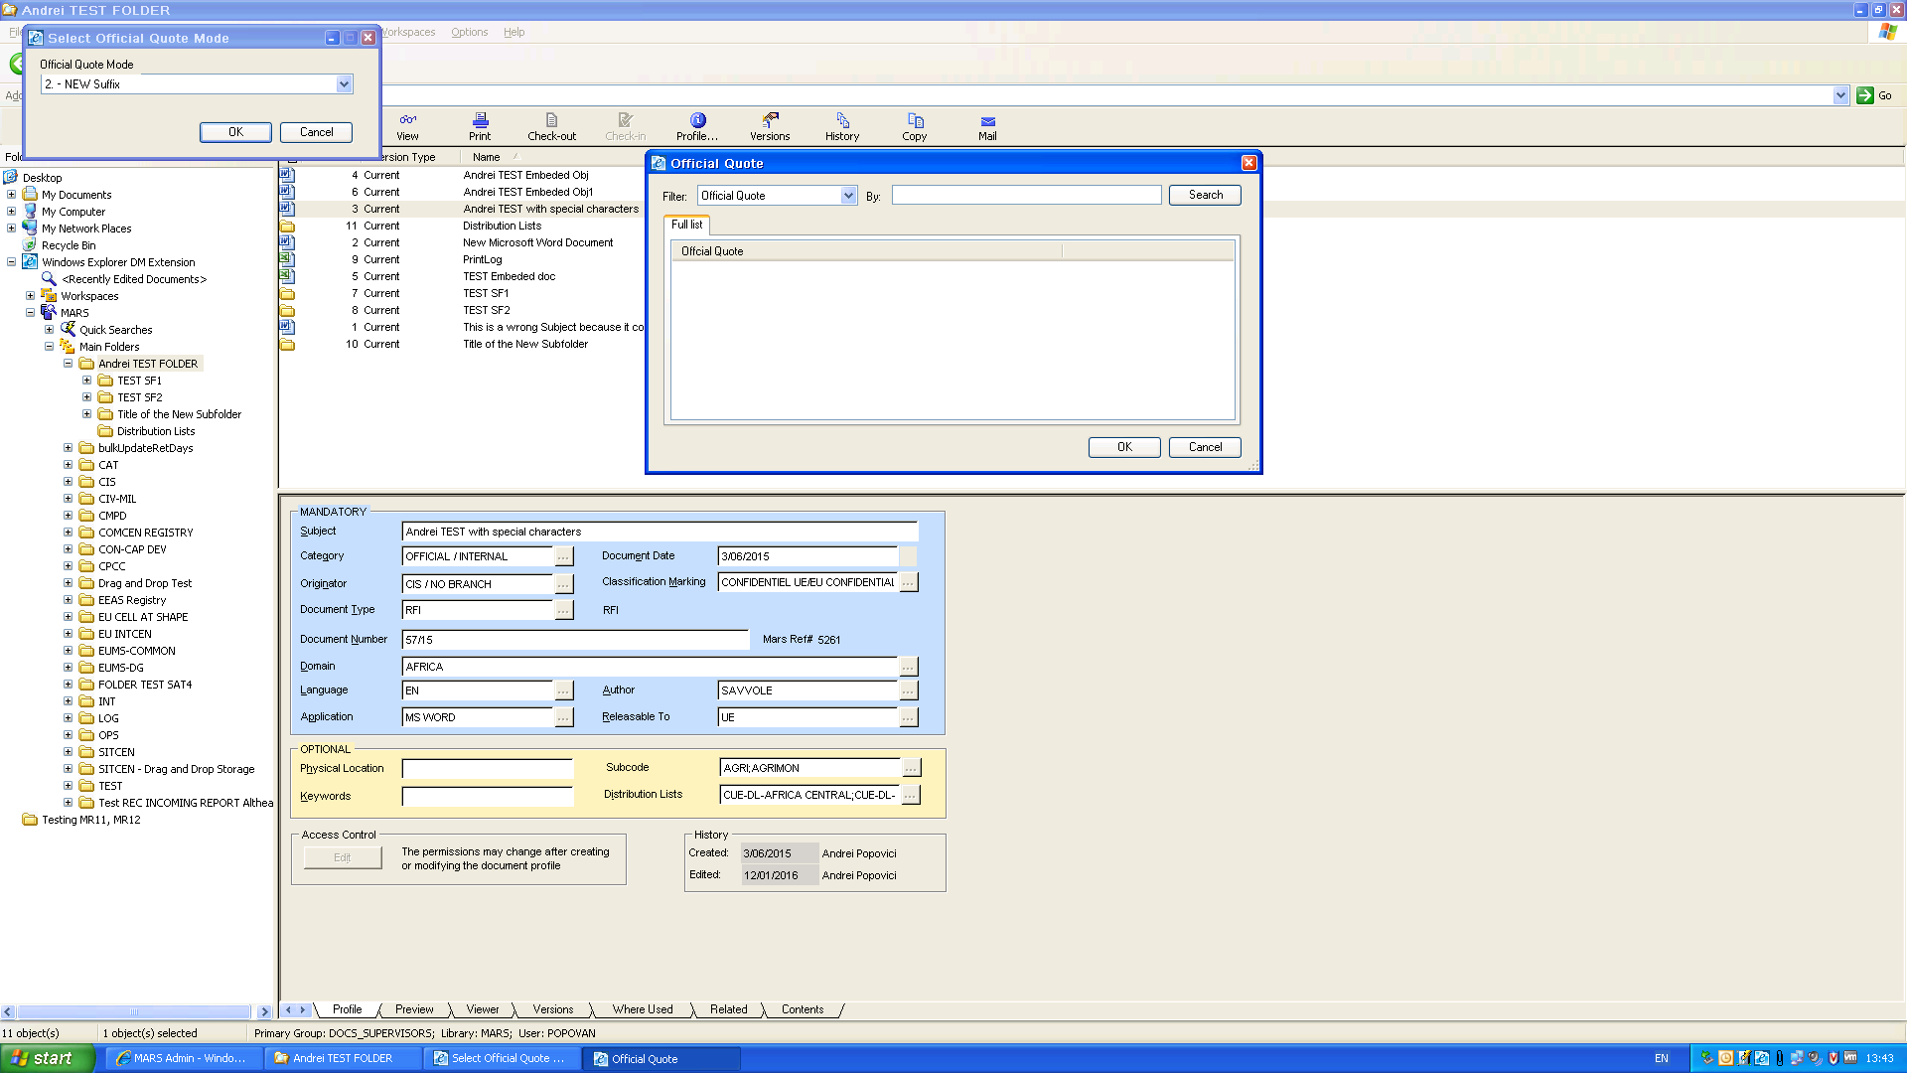

Result 2: BUG
We repeat the test after the second package of tests has been performed for EEAS, HR-COM, ADMIN within [TC-MR12-37] Official Quote Automation – FinalizeUpdate Official Quote (BUG) .
We expect the full list with all created Official Quotes available.

Testing sequence:
1. We receive this (only EEAS 00001 available):
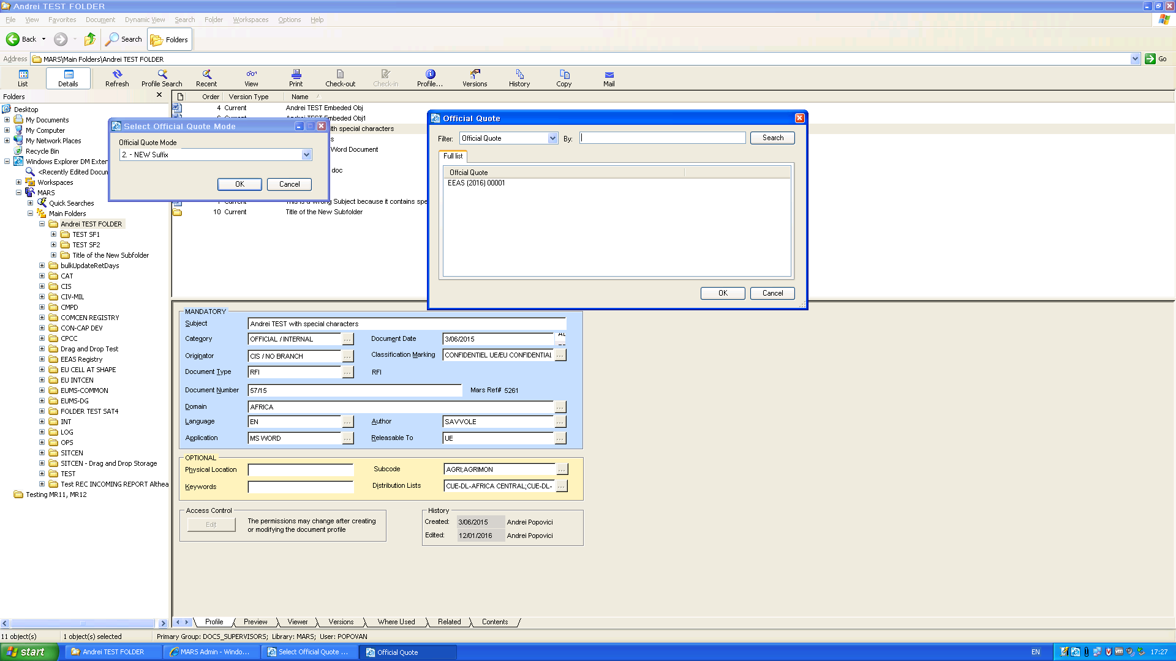

2. We click "Cancel", then choose again "New Suffix". Result:
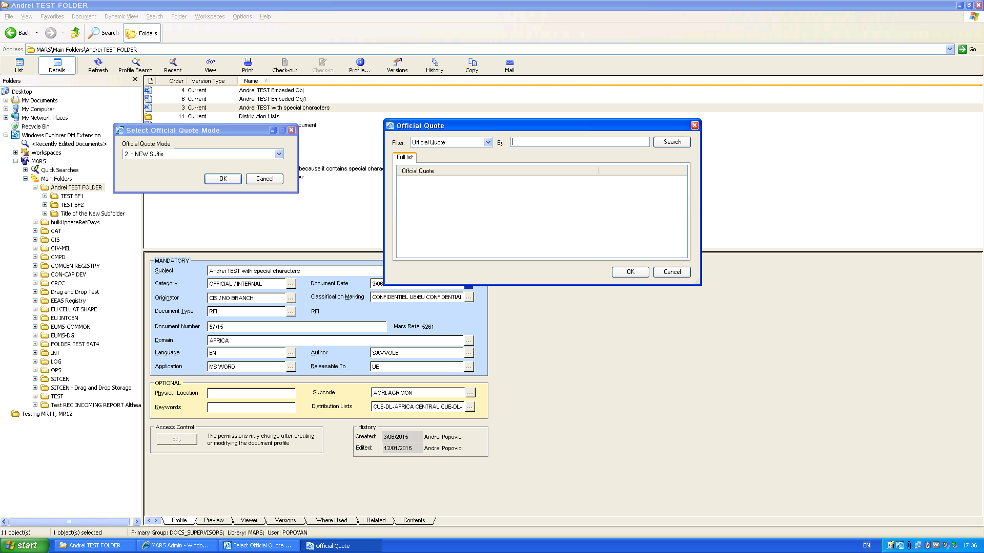

Conclusion:
Not only don't all the booked official quotes appear in the list, but the outstanding EEAS 00001 that appeared previously has dissapeared again from the list. The same situation encountered at Result 1.

